EMMA Optimization
Adjust MR results for Fieldnet uploads with 3 or 4 unit stepdown
SAP ISU EMMA
PJT12065

Analyst: Dean Bouarnay

History of Changes

Rev. | Date | Modified by | Comments
1.0 | 12/06/2016 | Dean Bournay | Initial Draft

Success Criteria
- Do not create IP22 EMMAs for Fieldnet meter read uploads for 01 or K1 meter read types where the new meter reading is 3 or 4 units below the previous reading.
- Do no adjust the meter read type of 01 or K1 meter read types where the new meter reading is 3 or 4 units below the previous reading.
- Reset the consecutive estimates counter for meters when receiving a meter read type of 01 or K1 meter read types where the new meter reading is 3 or 4 units below the previous reading, ensure the previous use of the existing Fieldnet reporting is unchanged.

Business/Sponsor Requirements
To adjust the read received through the Fieldnet interface which would eliminate the need for IP22 EMMAs which are getting generated for Fieldnet meter read uploads for 01 or K1 meter read types where the new meter reading is 3 or 4 units below the previous reading, but not adjust the MR type and ensure that this would reset the consecutive estimate counter for the Fieldnet report.

Stakeholder Requirement A.

Production ECP Example:

The below are two examples of accounts off by 3 and 4 units:

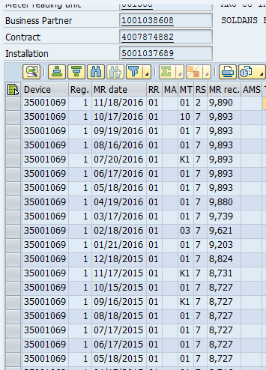

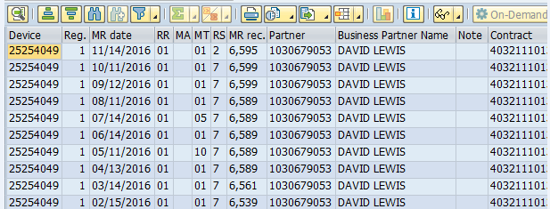

Solution (Functional) Requirement A.1

To adjust the read received through the interface (which would eliminate the need for an EMMA) to match the previous meter reading, but not adjust the MR type and ensure that this would reset the consecutive estimate counter for the Fieldnet report.

Need to add 3 and 4 units to the below area:

_____________________________________________________________________

Fieldnetmeter read upload
Existing subroutines CHECK_FOR_ROLLOVER and CHECK_FOR_ROLLOVER_2 in the program include LZ_ISU_DM_MR_UPLOADF01 adjust new meter reading results received by SAP from Fieldnet which are a MR Type of actual or verified (01 or K1) and 1 or 2 units below the prior read.

Matching the form and function of the existing subroutines, add 3 and 4 units below the prior read, adjusting the MR result to the prior result for actual or verified (01 or K1) reads without adjusting the MR type, leaving it as actual or verified.
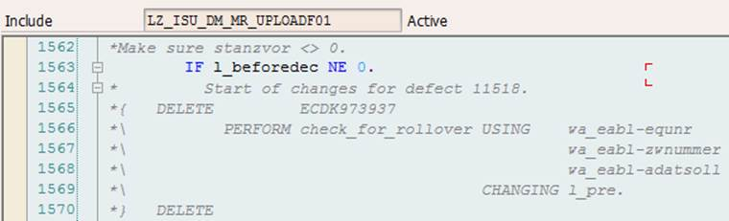
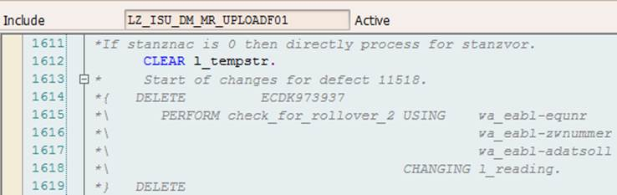

Testing Considerations

Sr. No. | Test Case | Expected results
1 | Upload Fieldnet meter read with 01 meter read type and meter reading three below previous meter read | The read is adjusted to the prior read, the meter read type is not, the consecutive estimate counter for the Fieldnet report is reset
2 | Upload Fieldnet meter read with K1 meter read type and meter reading three below previous meter read | The read is adjusted to the prior read, the meter read type is not, the consecutive estimate counter for the Fieldnet report is reset
3 | Upload Fieldnet meter read with 01 meter read type and meter reading four below previous meter read | The read is adjusted to the prior read, the meter read type is not, the consecutive estimate counter for the Fieldnet report is reset
4 | Upload Fieldnet meter read with K1 meter read type and meter reading four below previous meter read | The read is adjusted to the prior read, the meter read type is not, the consecutive estimate counter for the Fieldnet report is reset

Additional Considerations (Optional)
(don’t forget about these – create a full section if needed or include in existing sections above) | Notes/Detail (ref. docs, details, elaboration, contacts, etc)
Storage | Space for data, apps, etc; Consider multiple landscapes
Servers, Hardware | AST/Servers, devices, etc
Database | ORADBA
Performance & Capacity | Performance testing, risks, impact, network bandwidth, etc
Cyber Security
Vendor Management | Involvement in change, support, design assistance,
Environment/Landscapes | (prep, connectivity, other projects, timing, etc)
Impacts | to other Teams, Systems, Apps, Objects, etc.
Access | roles, AD groups, application access, different environments, etc
Security | passwords (people & programs), firewall, t-codes, etc
PI/XI alignment
Implementation/Cutover | timing, outages, tasks and sequence, contingency plan, conflict with other activities, etc
Web needs | Internet bandwidth, development, etc
BI/Reporting
Auditing | logging, controls
File Moves | BizTalk
Archiving | Data & file archiving, purging, retention, etc
Notifications – | Spool, email, pager, workflow, etc
Support Level | On-call, 24x7 vs business day, EARL/SM7 set up, etc
Distribution | Medic Packaging, etc
Training | Formal training, job aids, procedures; include for both end user and project/support staff
Communication
Manual Configuration, table changes | Timing; Authorization; Access;
Software/Licensing | Also yearly maintenance costs & considerations
Job Prose, Help Desk guidelines
Availability of the system | Planned & unplanned outages, disaster recovery, criticality
Skill needs | Include in each design section if possible – ABAP, web development, GIS, Oracle, etc
Conversion/Data Cleansing
Risks & Assumptions: This section should include things like predecessors, scope clarification, dependencies, resource expectations, etc. These may relate both to business issues and system design issues.
Constraints: This section should list all the constraints under which the solution has been designed. E.g. a certain database type must be used, Enterprise Architecture says we must do this way, cannot do VMware, etc

Risks | Description
Assumptions | Description
Constraints | Description

Supporting Documentation
Examples from ECP (Production):
Solution Design Document Validation/Approval

Name | Comments | Date

